**Nikon D3500 DSLR Camera with 18-55mm Lens**

* 24.2MP DX-Format CMOS Sensor
* 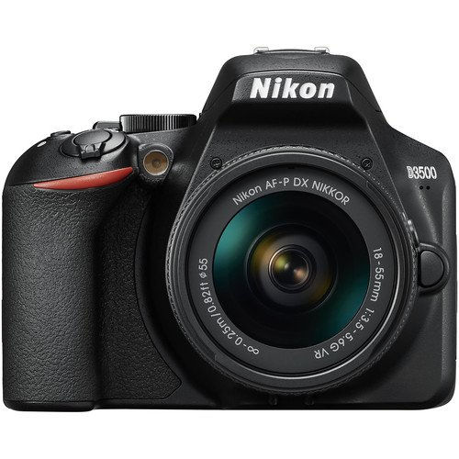EXPEED 4 Image Processor
* No Optical Low-Pass Filter
* Native ISO 100-25600; 5 fps Shooting
* 3.0″ 921k-Dot LCD Monitor
* Full HD 1080p Video Recording at 60 fps
* Multi-CAM 1000 11-Point AF System
* SnapBridge Bluetooth Connectivity
* Guide Mode and Special Effects
* AF-P DX 18-55mm f/3.5-5.6G VR Lens

**The Nikon D3500 DSLR Camera with 18-55mm Lens is an excellent entry-level option for those looking to step into the world of DSLR photography. Here's a breakdown of its features and key selling points:**

**Key Features:**

* **24.2MP DX-Format CMOS Sensor: Delivers high-resolution images with stunning clarity and detail.**
* **EXPEED 4 Image Processor: Offers fast performance, high-quality image processing, and improved noise reduction.**
* **No Optical Low-Pass Filter: Maximizes sharpness and image detail.**
* **Native ISO 100-25600: Provides excellent performance in both bright and low-light conditions, perfect for nightscapes or indoor shots.**
* **5 fps Shooting: Ideal for capturing fast-moving subjects, such as sports or wildlife.**
* **3.0″ 921k-Dot LCD Monitor: Provides a clear and bright display for reviewing your shots.**
* **Full HD 1080p Video at 60 fps: Captures high-quality video for filmmakers and vloggers.**
* **Multi-CAM 1000 11-Point AF System: Ensures sharp focus with accurate subject tracking.**
* **SnapBridge Bluetooth Connectivity: Easily transfer photos to your smartphone for sharing on social media and remote shooting.**
* **Guide Mode: A helpful feature for beginners, offering tips on how to use the camera and take great shots.**
* **AF-P DX 18-55mm f/3.5-5.6G VR Lens: Versatile zoom lens that covers a broad range of shooting situations from wide-angle to portraiture.**

**Benefits:**

* **Beginner-Friendly: The Guide Mode and user-friendly interface make it easy for newcomers to start capturing professional-quality photos.**
* **Compact & Lightweight: Weighs just 390g, making it a great choice for photographers on the go.**
* **Long Battery Life: Approximately 1200 shots per charge, ensuring you won’t run out of power during your photo sessions.**
* **Enhanced Social Sharing: With SnapBridge, you can instantly share photos via Bluetooth on your mobile devices.**
* **Free Workshops: Nikon Pakistan offers free Nikon School workshops, which will help you get the most out of your new camera.**

**Ideal for:**

* **Beginners: If you're just starting out with DSLR photography, this camera will help you build your skills with ease.**
* **Travel & Everyday Use: Its portability and simplicity make it perfect for travel, family outings, and everyday photography.**

**Overall, the Nikon D3500 is a fantastic option for those wanting to explore DSLR photography while offering the right balance of performance, ease of use, and portability. Plus, with the added benefit of Nikon's warranty and workshops, it's an excellent value.**